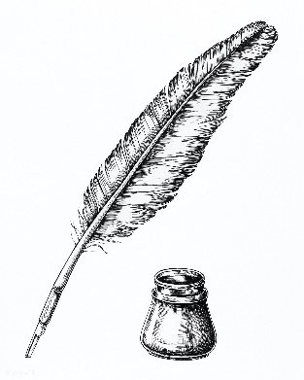
Screwtape Letters
Final Project

You will pretend to be Screwtape writing a letter to Wormwood. Wormwood’s current patient is a teenager in today’s society. The teenager DOES go to church, but also has a smart phone, their own car, and a job at the local fast-food joint.
- Choose a temptation the teenager will most likely face. Here are some examples:
  - Sharing inappropriate pictures over snapchat
  - Being asked to attend a Rated-R horror movie with friends
  - Lying to their parents about where they are going
  - Using their smart phone during church
  - Thinking about their friends / school / whatever during church
  - Too busy playing video games to pray
  - Come up with your own examples that I may not have thought of.
- Pretend to be Screwtape and write a letter to Wormwood about how to sway that teenager away from God (“The Enemy” according to Screwtape)
- Write a 1-page letter explaining to Wormwood how he can turn the teenagers attention away from God and how easy it is.

Your letter must include: (This is the checklist you should follow)
- The proper format (it should look like a letter)
- Whether or not Wormwood has been succeeding with the teenager thus far
- A basic summary of how teenagers are easy to sway
- A generalization of how teenagers are easy to tempt (the type of temptation you chose as the subject for your letter) / a definition of the type of temptation Wormwood should use with the teenager
- What Wormwood should NOT let the teenager do
- What thoughts Wormwood should put in their head
- How other people are helping that teenager to turn away from God (and how it is “good”)
- It must have the same format as The Screwtape Letters, so looking at it backwards, “The Enemy” is God, and “Our Father” refers to the devil.

 | A | B | C | I
Chapter questions complete  (35%) | All questions complete and thoroughly answered. 90-100% of questions answered | All questions complete, but hastily in many cases. Or 80%-89% of questions complete and thorough | 70-79% of questions complete | Less than 70% of questions complete
Quizzes (50%) | Average of 90-100% on all quizzes (quiz 1-10, quiz 11-25, quiz 26-end) | Average of 80-89% on all quizzes | Average of 70-79% on all quizzes | Average of less than 70% on all quizzes
Project letter (15%) | Met all 8 criteria listed on project guide | Met 80-89% of the criteria listed on project guide | Met 70-79% of all criteria listed on project guide | Met less than 70% of criteria listed on project guide.
Screwtape Letters Grading

