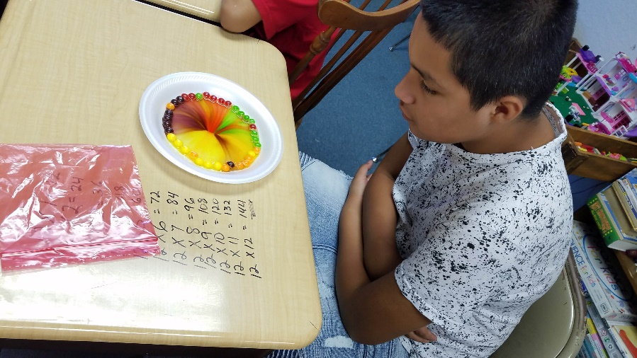
Evidence of Project-Based learning across grade levels

Grade: 4th
Subject: Science
Subtopic: Chemistry
Lesson: Color and light – students used skittles to see what colors reside as part of other colors.

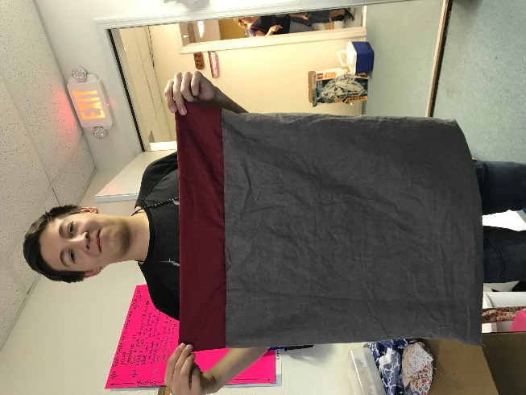
Grade: 9
Subject: Financial Algebra
Lesson: Sewing mini-project
Notes: Students created a “magic pillow case” where they measured, cut, and stitched French seam pillow cases. Some did not do a pillow case, but shorts, or a fanny pack.

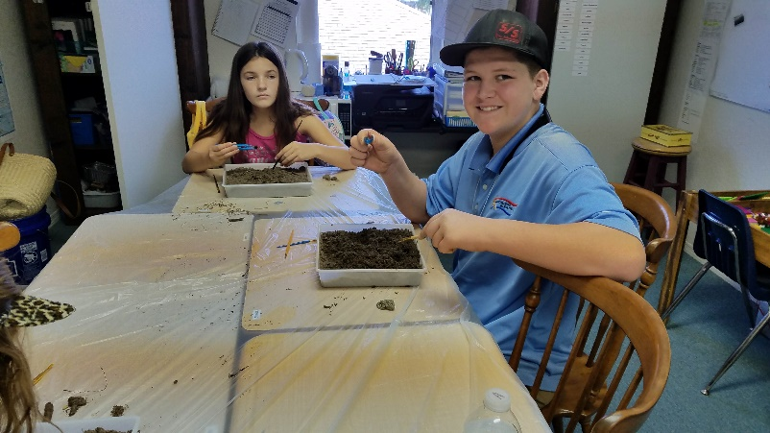
Grade: 6th
Topic: archeology
Notes: this was a before-school project for students who arrived early. They had the pleasure of digging for and identifying dino bones!

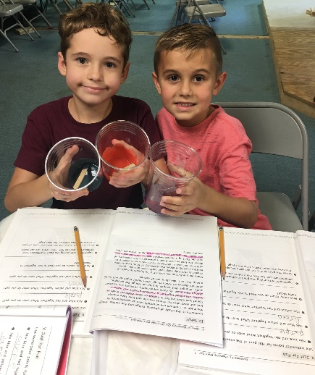
Grade: 1st , 2nd, and 3rd
Topic: Light and color
Notes: Curriculum used was “Real science for Kids” and the lesson was about what colors mix together to create secondary colors.

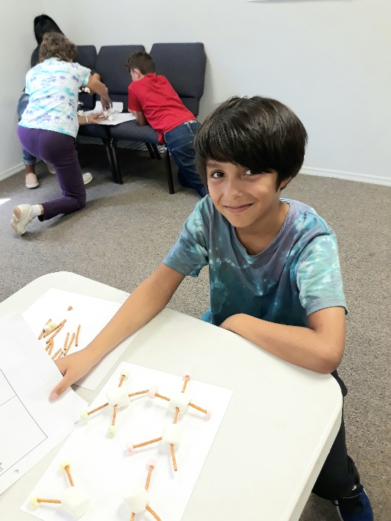
Grade: 5th/6th
Subject: Chemistry
Lesson: Create molecules… tasty ones

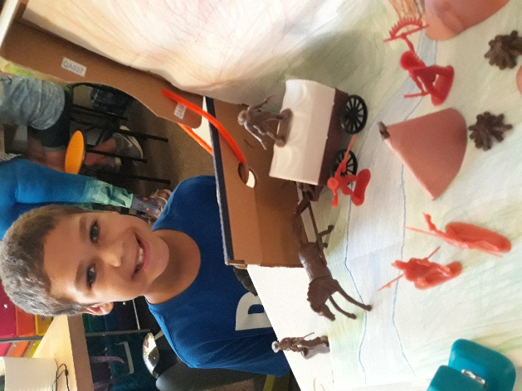
Grade: 6th / 7th
Subject: Florida History
Topic: Native Americans
Project: Create a diorama depicting a scene from Native American history

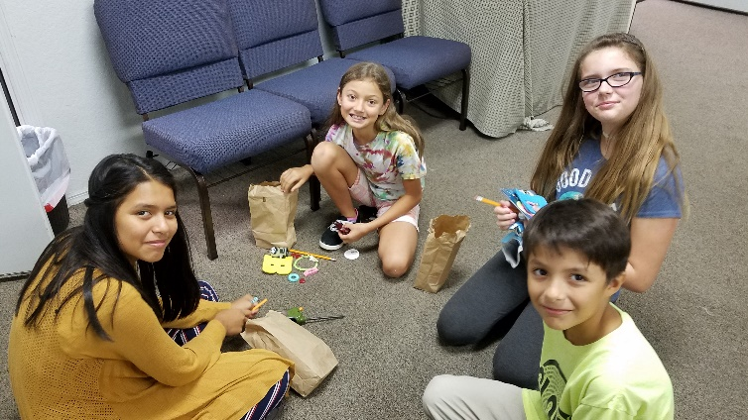

Grade: 6th / 7th
Topic: Barter and economics
Lesson: Students had bags of goodies and bartered with each other to get what they wanted.

